Flipper Zero
BadUSB Setup Guide

1. What Is BadUSB?
BadUSB is one of the built-in applications on the Flipper Zero, a small handheld multi-tool device used for learning about hardware and digital security. When plugged into a computer using its USB cable, the Flipper Zero can pretend to be a regular USB keyboard.
Because computers automatically trust keyboards, the Flipper Zero can use this app to type pre-written sequences of keystrokes automatically — much faster than a person could type them by hand, and without the person at the keyboard needing to type anything themselves. This is useful for automating repetitive tasks and for learning, in a controlled and legal setting, how devices like this work and why USB ports need to be treated carefully.
Use Responsibly:
Only connect the Flipper Zero and run BadUSB scripts on computers you own or have explicit permission to test. Using this feature on a device you do not own or without permission is illegal in most places.

2. What You Will Need
- A Windows computer to plug the Flipper Zero into
- A USB-A to USB-C cable
- A BadUSB script (“ducky script”) already saved on the Flipper Zero's SD card — this walkthrough uses one of Flipper's built-in demo scripts, Install_qFlipper_windows

3. Step 1 — Setup: Open the BadUSB App
Everything in this step happens directly on the Flipper Zero's own screen. Use the directional pad (the round button with arrows) to move up and down, and press the center button to select.

3.1 Select USB
- On the Flipper Zero, return to the main menu by pressing Back repeatedly.
- Scroll down using the directional pad until you see the folder list shown below.
- Highlight USB and press the center button to open it.
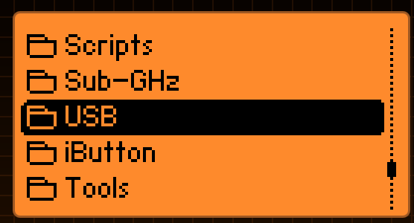
Figure 1 — The main menu with USB highlighted.

3.2 Select Bad USB
- Inside the USB folder, highlight Bad USB and press the center button to open it.
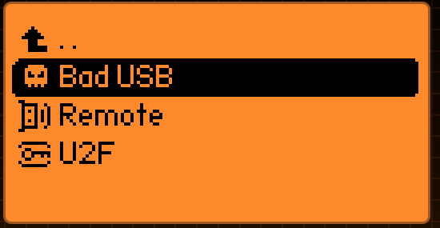
Figure 2 — The USB submenu with Bad USB highlighted, alongside Remote and U2F.
Opening Bad USB brings up a list of any saved scripts stored on the device's SD card.

4. Step 2 — Choose a Payload
From the Bad USB script list, highlight the desired script and press the center button to select it.
Reminder:
Only run a script on a computer that belongs to you or that you have clear permission to test.
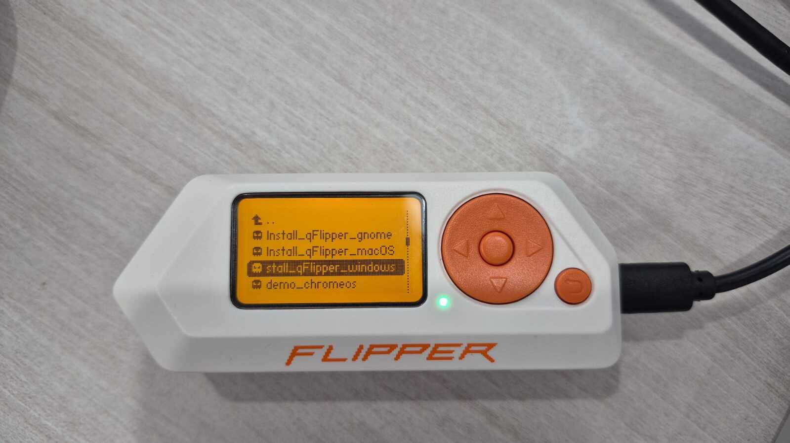
Figure 3 — The Bad USB script list on the Flipper Zero, with Install_qFlipper_windows highlighted for selection.

5. Step 3 — Payload Progress
After the script is selected and run, the Flipper Zero switches to a status screen for that script. From here it acts as a USB keyboard and types out the script's keystrokes on the connected computer, without any further input needed on the Flipper Zero itself.
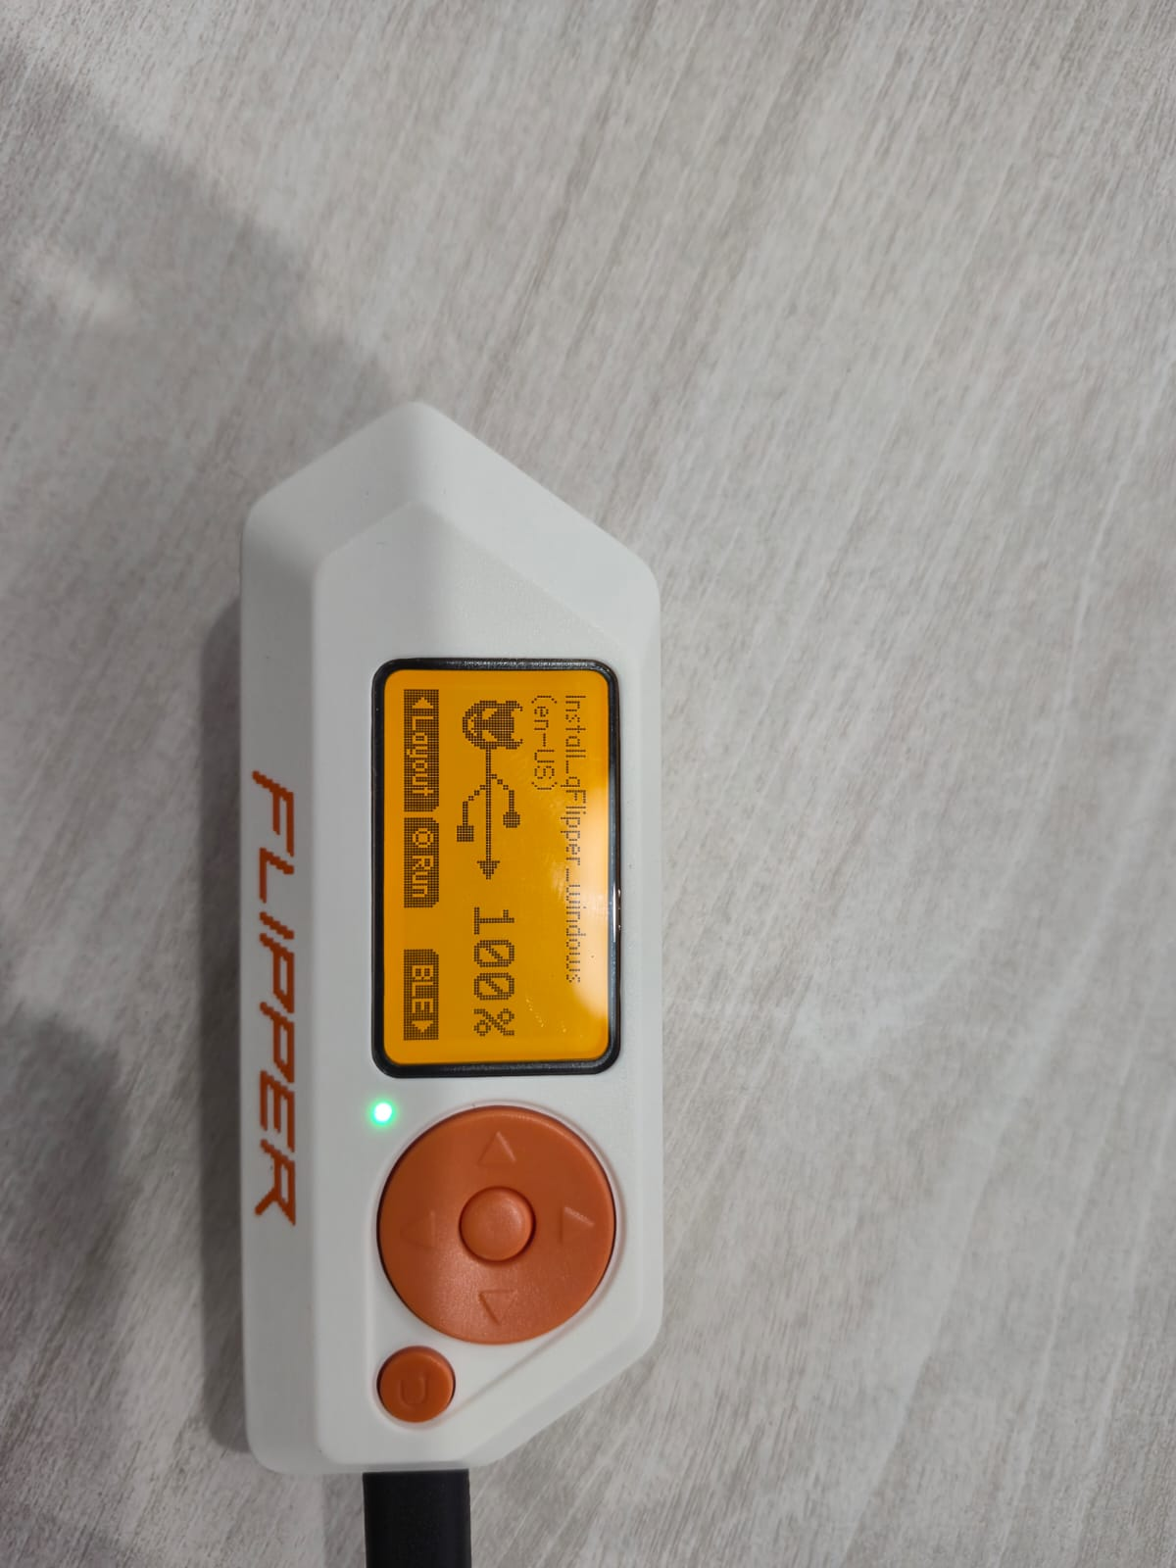
Figure 4 — The Install_qFlipper_windows script's run screen on the Flipper Zero, with Layout, Run, and BLE options and the battery shown at 100%.

6. Step 4 — Result
On the connected computer, the keystrokes typed by the Flipper Zero open PowerShell and run automatically, with no one needing to type them by hand. The screen below shows what appeared on the computer after the script ran.
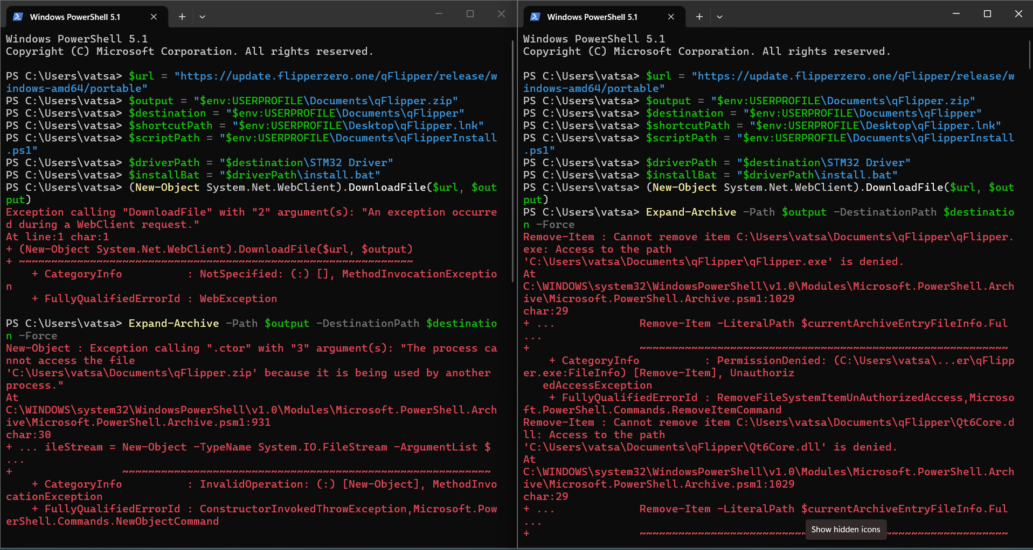
Figure 5 — The PowerShell window on the target computer after the script ran, showing the commands it typed and their output. The error messages here mean the script did not complete cleanly on this attempt (see note below).
Note:
The errors shown — “being used by another process” and “Access to the path is denied” — are common on a first run and typically happen when a previous partial attempt left files locked or in place. Closing any open windows to the target folder, deleting any partially-created files, and re-running the script usually resolves this.

7. Quick Recap

- Setup: opened USB → Bad USB on the Flipper Zero.
- Chose the Install_qFlipper_windows payload from the script list.
- Watched the payload's run screen as it typed keystrokes on the connected computer.
- Reviewed the result in the PowerShell window on the target computer.

8. Custom Payload Testing

Testing custom payloads allows you to create your own DuckyScript files to automate specific tasks, ranging from basic text entry to complex configuration changes.

8.1 Creating a Custom Payload
Write your custom DuckyScript using any plain text editor, such as Notepad on Windows or nano on Linux. Ensure the script follows standard Rubber Ducky syntax (e.g., STRING, ENTER, DELAY) and save the file with a .txt extension.

8.2 Connecting Flipper to Flipper Lab
Open the Flipper Lab web application in your browser and connect your Flipper Zero to your computer via USB or Bluetooth. This connection allows you to manage files on the device's SD card directly from your browser without needing to remove the microSD card.
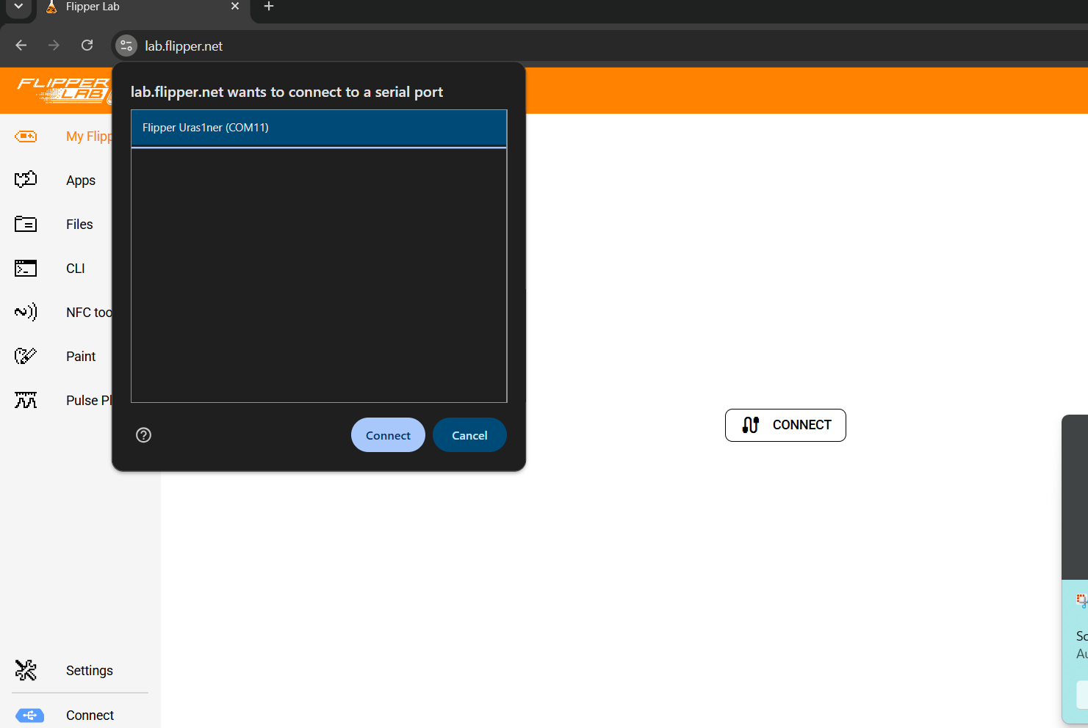

Figure 6 — Connecting the Flipper Zero to Flipper Lab.

8.3 Uploading the Custom Payload
Once connected, use the file upload option within Flipper Lab to browse your computer and select your saved .txt DuckyScript file. Upload it directly into the device's badusb folder on the SD card.
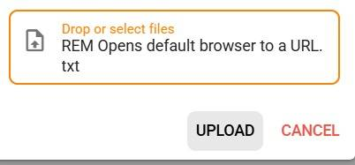
Figure 7 — Uploading the custom payload via Flipper Lab.

8.4 Verifying the Transfer
After the upload completes, confirm the file appears in the correct folder using either Flipper Lab's file browser or the qFlipper desktop app. This step ensures the payload is available before attempting to run it on the device.

Figure 8 — Confirming the custom payload file has been transferred successfully.

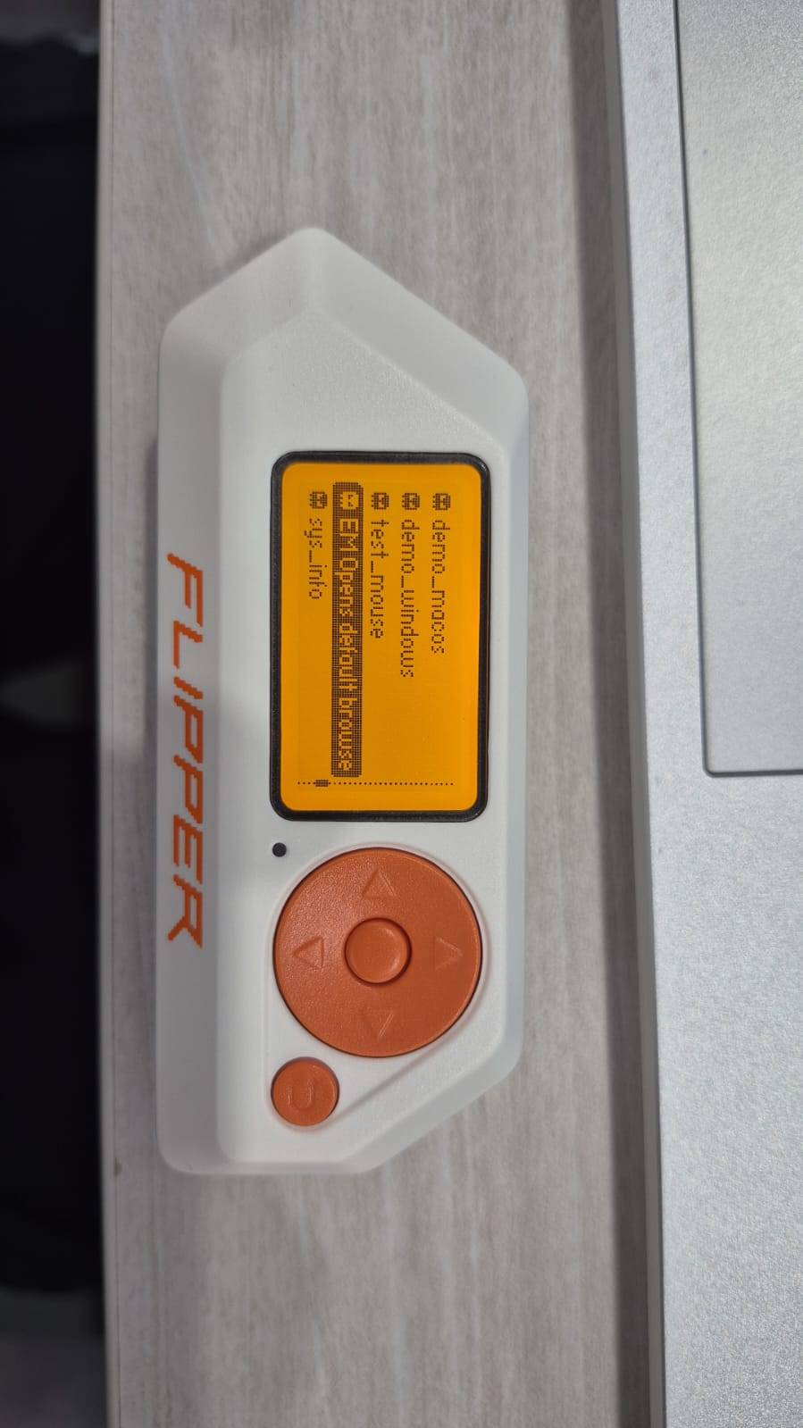

8.5 Connecting to the Target Machine

Plug your Flipper Zero into the target computer using a USB-C cable. On the Flipper Zero, press the center button to access the main menu, scroll down, and select the USB folder.
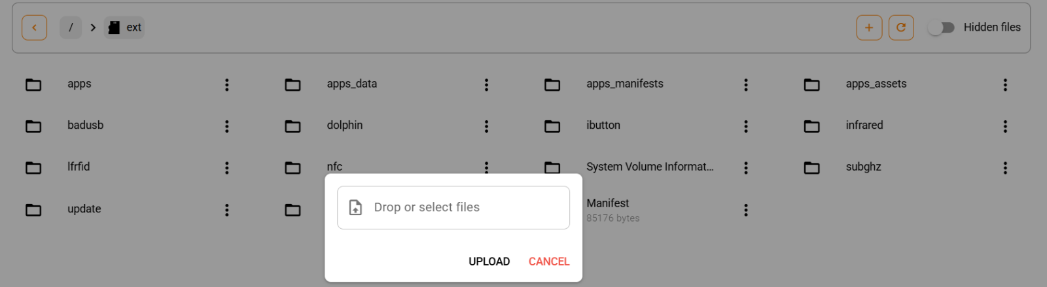
Figure 9 — Highlighting and selecting the USB folder from the main menu.

8.6 Opening the BadUSB App
Inside the USB folder, locate and select the Bad USB application. This will parse the SD card and bring up your list of available scripts.
Figure 10 — Opening the Bad USB application.

8.7 Selecting the Custom Script
Scroll through the file list to locate the custom .txt payload you uploaded earlier. Highlight the file and press the center button to open its execution menu.
Figure 11 — Selecting the custom payload from the script list.

8.8 Running the Payload
Press the center button again to execute the payload. The Flipper Zero will immediately begin acting as a virtual keyboard, sending the programmed keystrokes to the connected computer.
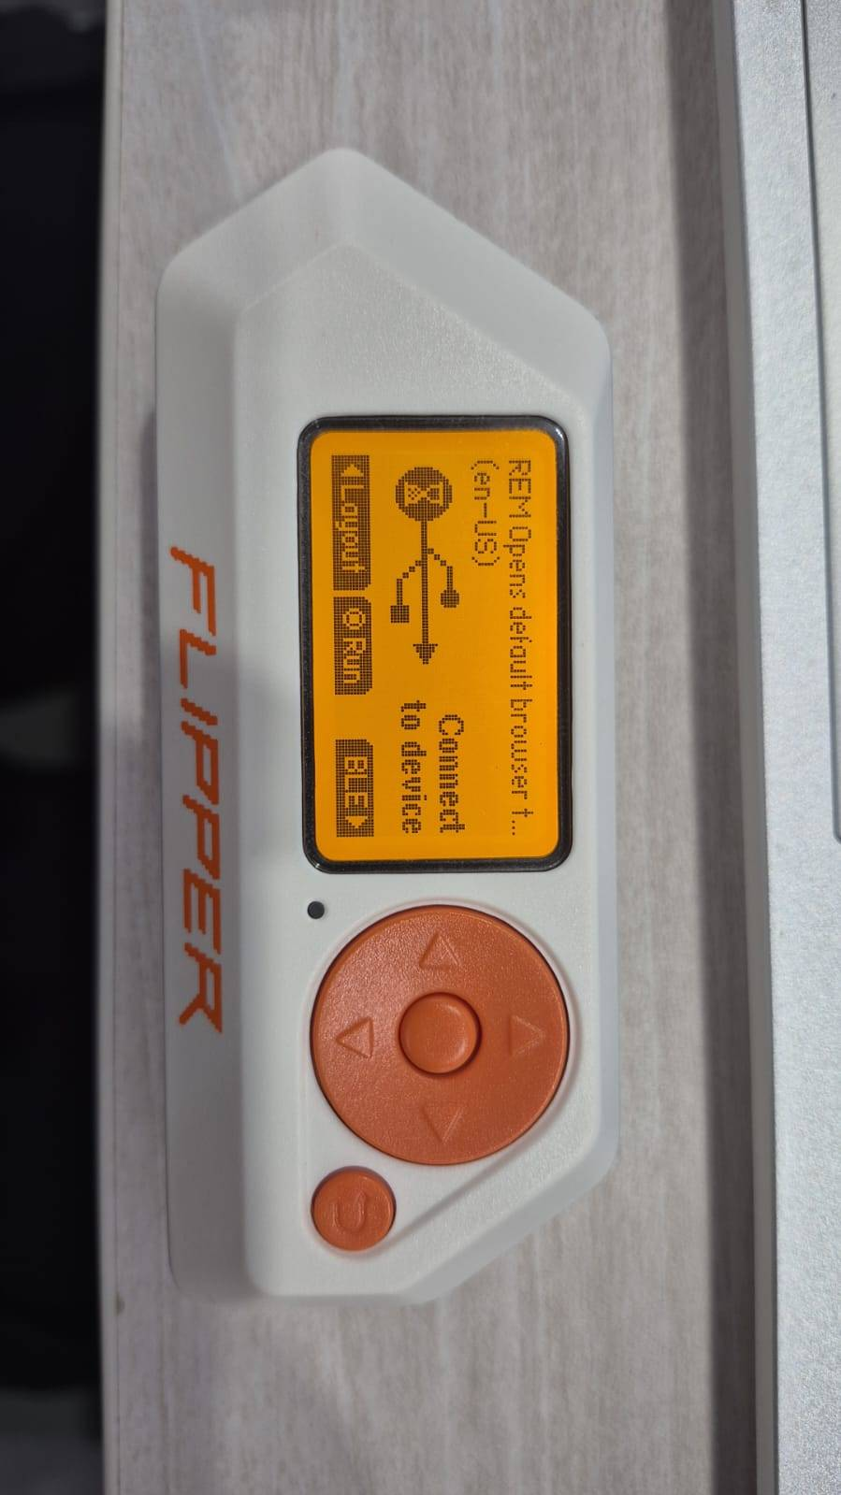

8.9 Monitoring Execution
Watch the Flipper Zero screen as the payload runs to track its progress. During this time, avoid interacting with the target computer's physical keyboard or mouse to prevent interrupting the automated sequence.
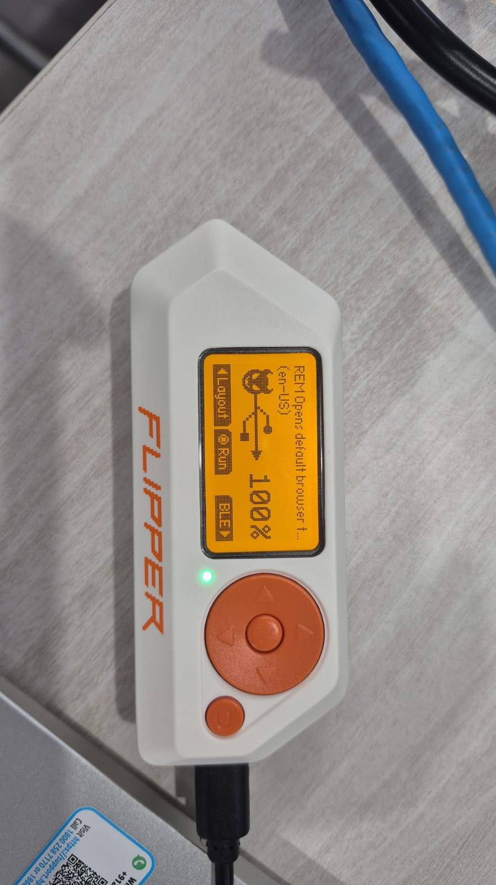

Figure 12 — Monitoring the script execution progress on the Flipper Zero display.

8.10 Observing Target Behavior
Observe the target machine to ensure the keystrokes are executing as intended. For example, if your script opens a terminal and types a command, verify the window appears on screen and the text is entered correctly.

8.11 Verifying the Results
Once the Flipper Zero indicates the run is complete, review the final output on the target machine. Check for any errors, review generated logs, and adjust your DuckyScript for troubleshooting if the desired outcome was not achieved.

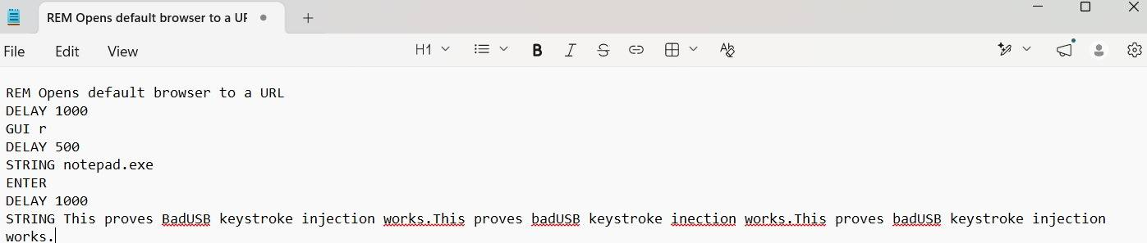

Figure 14 — Verifying the final result and output of the custom payload execution.

9. Quick Recap — Custom Payload Testing
Created a custom DuckyScript payload using a plain text editor.
Created a custom DuckyScript payload using a plain text editor.
Connected the Flipper Zero to Flipper Lab and uploaded the payload to the badusb folder.
Verified the file transfer before running the script.
Connected the Flipper Zero to the target machine and opened USB → Bad USB.
Selected and ran the custom payload, monitoring execution on both devices.
Verified the final results and troubleshot any errors on the target machine.

